Overview:
The NetResource API implements a way to manage downloading content from a web server. It both encapsulates the entire ProtoHttpGet process to fetch resources from a web server and manages an optional cache which will help to prevent unnecessarily downloading a resource multiple times.

Description:
NetResource is designed as an easy way to download content from a webserver. Resources to be downloaded (.jpg, .gif, .swf, etc.) are referenced by two unsigned integers, one used as a token to represent the type and one used as a hexadecimal number to represent the identity. Thus, filenames wind up in the format ‘type-02468ACE’. The type of content downloaded then becomes immaterial – all resources are handled as binary data. On the server, resources using these names will likely be symbolically linked to the real resources, such as full_page_image.jpg or animation.swf, etc.

Basic Usage
As with other DirtySock modules, basic module management is performed with NetResourceCreate() and NetResourceDestroy(). Likewise, the create function returns a module state variable which should then be passed to all other NetResource calls, including the destroy function which will free any memory created by the create and subsequent NetResource calls.

A base URL is passed to NetResourceCreate() which signifies a location where resources are stored. Resources, when fetched by NetResource, will be fetched from the server by forming a string out of the type and identifier values and appending this to the end of the base URL. The base URL should not include http:// or a trailing ‘/’. An example of a correct base URL would be “dirtysock.ea.com/temp”. Resources are all stored on the server in a single directory.

NetResource has the capability to cache downloaded data if desired. By default, no caching is enabled. In order to use this feature, call NetResourceCache() and pass it an allocated buffer and buffer size in bytes. This cache will then be used for subsequent resource download requests. Call NetResourceCache() again with a new buffer and size to resize the cache, or NULL to disable caching. If the cache is to be resized, references to the contents in the old cache will be lost and the new cache will be used. The caller is responsible for both allocating the cache buffer and freeing it after NetResourceDestroy() is called or NetResourceCache() is called with a replacement cache buffer.

Resource fetching is managed by using one or more NetResourceXferT structures. The caller is responsible for allocating and freeing the NetResourceXferT structures which are passed to the NetResourceFetch call. These structures should not be freed until the fetch has completed (the FINISH state has been reached). The data inside these NetResourceXferT structures should be used by the game code to detect download status, amount of data received, and size of the resource among other things. Convenience variables are also provided in the XferT structure for game team use and may be used to track things like state variables and memory buffers. Just before calling the user callback, some of the fields are copied from internal DirtySock NetResource structures, including resource type (uType) identity (uIdent) status (iStatus) total size of the resource (iLength) and the resource sequence number (iSeqNum).

To download content using NetResource, use NetResourceFetch() or NetResourceFetchString(). It is necessary to pass in either numeric type/identity of the resource or a string containing these values, as well as an allocated NetResourceXferT structure. Also pass a callback to use in order to report fetch progress, a timeout for the http transaction, and a priority to use when storing the resource in the cache, if the cache is enabled. Currently, there are three available cache priorities, applicable only if caching is enabled:
NETRSRC_PRIO_DONTCACHE: Does not cache the resource.
NETRSRC_PRIO_KEEPIFPOSSIBLE: Does its best to keep the resource in the cache
NETRSRC_PRIO_DEFAULT: Attempt to cache the resource if there is room available.

Resources will be deleted from the cache to make room for new resources based first on priority, then on the number of times the resource was accessed, and finally by age (last access time) of the resource.

If NetResourceFetchString() is used, be sure to pass in a string with the following format:
“<4 character type>-<numeric identifier>”. Additionally, a prefix of “netres:” will be ignored. Here is an example string: “netres:imag-001”.

The callback passed into NetResourceFetch() or NetResourceFetchString() will be called with progress regarding a NetResourceXferT transfer. Thus, it is up to the caller to check the uType and uIdent in the NetResourceXferT structure to determine which resource download the callback pertains to. The progress (status) of the download is stored in the iStatus field in the NetResourceXferT structure. The possible states are listed in the API as NETRSRC_STAT_XXXX. The following state diagram outlines all possible state transitions. Large blue arrows indicate the normal, expected path. Smaller red connections indicate error paths.

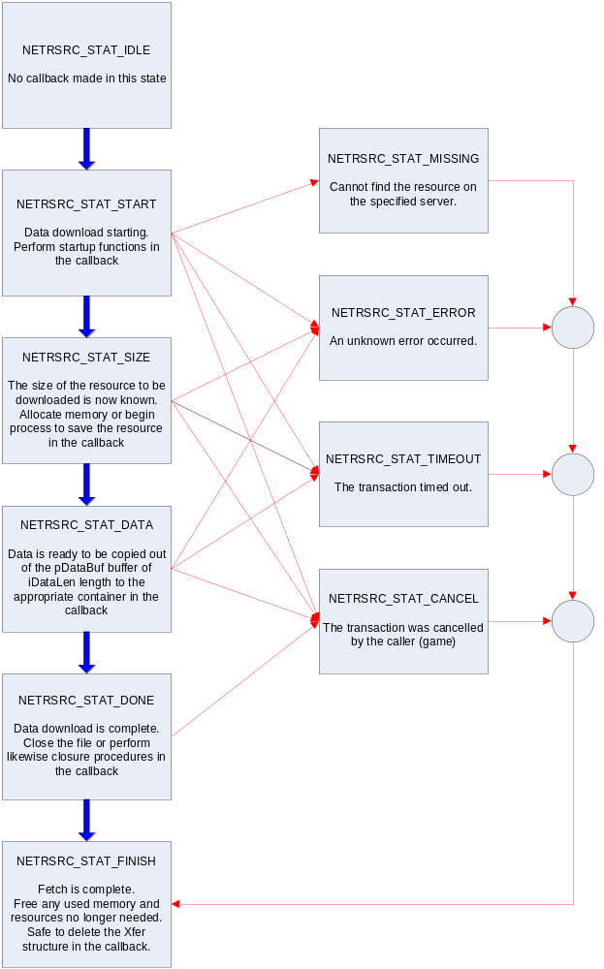

If the resource is cached, this entire sequence (START, SIZE, DATA, DONE, FINISH) will be completed in one Update cycle. Additionally, the fetch command will check the cache and, if the item is already in the cache, any current operation in progress will be immediately set aside to run the cached entry to completion through all these states. When this is complete, the previous operation will continue where it left off.

If caching is disabled, each DATA callback will provide a pointer into memory and a length for the data at that memory location. The calling code should copy this data out into a separate buffer. It is recommended that the pBuffer variable, part of the associated NetResourceXferT structure, be used to keep track of a larger region of memory which is capable of holding the entire resource. The DONE state signifies that all data has been received. With caching disabled, the pDataBuf and iDataLen is only valid in a DATA status callback.

If caching is enabled, each DATA callback will cause data to be stored in the NetResource (user-provided) cache. In this case, pDataBuf and iDataLen will reflect the amount of data in the cache. At the DONE state, the pDataBuf and iDataLen will be valid and can be used DURING THE CALLBACK ONLY to do something like decompress an image out of the cache. Once the callback has completed, it is likely that the pointer returned in the callback will become invalid as memory cache compacting occurs as new resources are requested. !!!IMPORTANT!!!: Keeping the pointer to the cache entry provided in the callback in the DONE state after the DONE callback has completed could cause unexpected system behavior and should be avoided.

It is not necessary to call a NetResourceUpdate function – an idle callback is registered internally with NetConnIdle() in order for NetResource to get processing time during transfers. As is true with other DirtySock modules, NetConnIdle() should be called at regular frequencies in order to ensure acceptable performance – once per update cycle (~60Hz preferred, 30Hz minimum) is usually sufficient.

If at any time a fetch needs to be cancelled, the NetResourceCancel() function should be used, passing in the sequence number associated with the transaction to be cancelled. If the resource is currently being downloaded and cached, any cache entries will be destroyed.

Example Usage

Listed below are several pseudo-code scenarios in which NetResource could be used:

This is a very simple implementation:

// create the module state
NetResourceCreate("dirtysock.ea.com/temp");
// fetch a resource from the server named “imag-00000001”
NetResourceFetch('imag',1,NETRSRC_PRIO_DONTCACHE);
// wait until the fetch completes to call destroy
NetResourceDestroy();

This is a more complex situation where multiple resources are requested. NetResource will maintain a list of the resources and fetch each one in sequence, pulling from its internal cache if possible:

// create the module state
NetResourceCreate("dirtysock.ea.com/temp");
// create a cache
char *pBuffer = malloc(50000);
NetResourceCache(pBuffer,50000);
// fetch some resources
NetResourceFetch('imag',1,NETRSRC_PRIO_DONTCACHE);
// this next xfer will pull from cache and re-set the priority to KEEP
NetResourceFetch('imag',1,NETRSRC_PRIO_KEEPIFPOSSIBLE);
NetResourceFetch('imag',2,NETRSRC_PRIO_KEEPIFPOSSIBLE);
NetResourceFetch('imag',3,NETRSRC_PRIO_DEFAULT);
// wait until all fetches complete to call destroy
NetResourceDestroy();

The following is a pseudo-code example of how a callback handler might be implemented:

memset(&xfer, sizeof(xfer));
xfer.pRefPtr1 = my_window_identifier;
xfer.pRefVal1 = my_image_identifier;
NetResourceFetch(pState, &xfer, ‘tour’, 2, &MyHandler, 15000);

void MyHandler(NetResourceT *pState, NetResourceXferT *pXfer, void *pRefPtr, int iEvent, void *pDataBuf, int iDataLen)
{
// the callback always gets the START event first
if (pXfer->iStatus == NETRSRC_STAT_START)
{
// nothing special at transfer startup
}

// the callback gets a SIZE event so it can allocate its buffer
// (in the case of a transfer error, the SIZE event may not occur)
if (pXfer->iStatus == NETRSRC_STAT_SIZE)
{
// allocate a storage buffer for the incoming data
pXfer->pBuffer = malloc(pXfer->iLength);

}

// the callback gets a DATA event as data is received from the server
// (in the case of a transfer error, the DATA event may not occur)
if (pXfer->iStatus == NETRSRC_STAT_DATA)
{
// copy data into our buffer
memcpy(pXfer->pBuffer+pXfer->iOffset, pDataBuf, iDataLen);
}

// the callback gets a DONE event when the resource is successfully received
// (in the case of a transfer error, the DONE event may not occur)
// (after the DONE, the callback will get a FINISH)
if (pXfer->iStatus == NETRSRC_STAT_DONE)
{
// extract application specific window/item info
void *pWindowThing = pXfer->pRefVal1;
int iWindowIdent = pXfer->iRefVal1;
// display the data in some application specific way
MyDisplayFunction(pWindowThing, iWindowIdent);
}

// the callback gets a MISSING event if the requested resource is not found
// (after the MISSING, the callback will get a FINISH)
if (pXfer->iStatus == NETRSRC_STAT_MISSING)
{
// the requested resources is not on the server
}

// the callback gets a TIMEOUT event if the transfer failed to complete in time
// the callback gets a ERROR event if the transfer failed for reason other than timeout
// (after the ERROR, the callback will get a FINISH)
if (pXfer->iStatus == NETRSRC_STAT_ERROR)
{
// the transfer failed for some reason other than timeout
// might show special “error” graphic
}
// the callback gets a TIMEOUT event if the transfer failed to complete in time
// (after the TIMEOUT, the callback will get a FINISH)
if (pXfer->iStatus == NETRSRC_STAT_TIMEOUT)
{
// application timeout handler
// might show special “error” graphic
}

// the callback gets a CANCEL event if NetResourceCancel is called
// (after the CANCEL, the callback will get a FINISH)
if (pXfer->iStatus == NETRSRC_STAT_CANCEL)
{
// application called cancel function
}

// the callback always gets the FINISH event last so it can free resources
if (pXfer->iStatus == NETRSRC_STAT_FINISH)
{
// free any buffer we allocated
if (pXfer->pBuffer != NULL)
{
free(pXfer->pBuffer);
}
}
}

API:

/*H********************************************************************************/
/*!
\File netresource.h

\Description
Resource downloader/caching utility

\Notes
As several GDDs now require the use of dynamic downloaded images,
some unified method of downloading these resources is required.
The network resource manager would provide game titles with a simple
method to download arbitrary resources (binary objects of any
underlying type) via a simple type/identifier combination. Each game
will have its own unique type/identifier mapping to avoid conflicts
with other titles.

\Copyright
Copyright (c) Electronic Arts 2004. ALL RIGHTS RESERVED.

\Version 12/15/2004 (jfrank)
*/
/********************************************************************************H*/

#ifndef _netresource_h
#define _netresource_h

/*** Include files ****************************************************************/

/*** Defines **********************************************************************/

#define NETRSRC_STAT_IDLE (0) //!< not doing anything
#define NETRSRC_STAT_START (1) //!< start of transfer
#define NETRSRC_STAT_SIZE (2) //!< size of object known (allocate buffer)
#define NETRSRC_STAT_DATA (3) //!< append data to buffer
#define NETRSRC_STAT_DONE (4) //!< transfer is complete (hand off data)
#define NETRSRC_STAT_ERROR (5) //!< transfer failed
#define NETRSRC_STAT_CANCEL (6) //!< transfer was canceled (release buffer)
#define NETRSRC_STAT_TIMEOUT (7) //!< transfer timed out
#define NETRSRC_STAT_MISSING (8) //!< resource is not on the server
#define NETRSRC_STAT_FINISH (9) //!< finished – release resources

#define NETRSRC_PRIO_DONTCACHE (-1) //!< don't cache the incoming data whatsoever (one-time use data to download, like rosters etc.)
#define NETRSRC_PRIO_DEFAULT (0) //!< default - don't do anything special to keep or discard data in the cache
#define NETRSRC_PRIO_KEEPIFPOSSIBLE (1) //!< keep the data in the cache if at all possible (commonly used data)

#define NETRSRC_ERROR_NONE (0) //!< no error
#define NETRSRC_ERROR_BADNAME (-1) //!< bad resource string name passed to fetch function

#define NETRSRC_CACHESTATUS_LOADING (0x01) //! loading from the cache
#define NETRSRC_CACHESTATUS_SAVING (0x02) //! saving to the cache

/*** Macros ***********************************************************************/

#define NETRSRC_PRINTFTYPEIDENT(uType, uIdent) ((uType) >> 24) & 0xFF, \
((uType) >> 16) & 0xFF, \
((uType) >> 8) & 0xFF, \
(uType) & 0xFF, (uIdent)

/*** Type Definitions *************************************************************/

// NetResource state structure
typedef struct NetResourceT NetResourceT;

// NetResource Transfer Descriptor Structure
typedef struct NetResourceXferT NetResourceXferT;

// Callback prototype used for download resources
typedef void (NetResourceCallbackT)(NetResourceT *pState, NetResourceXferT *pXfer,
void *pDataBuf, int iDataLen);

//! NetResource Transfer Descriptor Structure
struct NetResourceXferT
{
//! public data monitored by the game
int iSeqNum; //!< sequence number for the transaction
unsigned int uType; //!< type of the resource
unsigned int uIdent; //!< ident of the resource
int iStatus; //!< NETRSRC_STAT_* (game team monitors this to determine what state we are in)
int iLength; //!< total object size (set by NetResource when the SIZE command returns and used by the game team to allocate a chunk of memory for pBuffer)
short iPriority; //!< priority in the cache
unsigned short uCacheStatus; //!< cache status (SAVING or LOADING)

//! convenience data: user-allocated and user-managed data (not used by NetResource at all)
void *pBuffer; //!< buffer pointer for game - the game will allocate memory for this variable after SIZE status when size of incoming data is known.
unsigned int uAmtReceived; //!< used by game - for keeping track of how much data has been received
int iRefVal1; //!< custom user data - The following values are for game-team use
int iRefVal2; //!< custom user data - (possibly used for window ID so the user-defined callback knows what to do
void *pRefPtr1; //!< custom user data - with the resource when it is asynchronously received)
void *pRefPtr2; //!< custom user data
};

/*** Variables ********************************************************************/

/*** Functions ********************************************************************/

#ifdef __cplusplus
extern "C" {
#endif

// Create network resource manager instance.
NetResourceT *NetResourceCreate(const char *pHome);

// Destroy the network resource manager instance.
void NetResourceDestroy(NetResourceT *pState);

// Set the external cache buffer
int NetResourceCache(NetResourceT *pState, void *pCacheBuf, const int iCacheLen);

// Start a network transfer from a number based resource
int NetResourceFetch(NetResourceT *pState, NetResourceXferT *pXfer,
const unsigned int uType, const unsigned int uIdent,
NetResourceCallbackT *pCallback, const int iTimeout,
const int iPriority);

// Start a network transfer from a string based resource, return sequence number
int NetResourceFetchString(NetResourceT *pState, NetResourceXferT *pXfer,
const char *pResource,
NetResourceCallbackT *pCallback, const int iTimeout,
const int iPriority);

// Cancel an in-progress network transfer using the sequence number from Fetch
void NetResourceCancel(NetResourceT *pState, int iSeqNum);

#if CODE_DEBUG
// useful debugging routine for printing the contents of the cache
void NetResourceCachePrint(NetResourceT *pState);
#endif

#ifdef __cplusplus
};
#endif

#endif // _netresource_h

